Flight Prices Analysis

Using Hive and Hadoop

Authors: Ragi Dave, An Mach, Ankita Hasmukhbhai Savaliya, Bhumika Suvagia

Department of Information Systems, California State University, Los Angeles

CIS 5200 – System Analysis and Design

[rdave4@calstatela.edu](mailto:rdave4@calstatela.edu), [amach3@calstatela.edu](mailto:amach3@calstatela.edu), [asavali2@calstatela.edu](mailto:asavali2@calstatela.edu), [bsuvagi@calstatela.edu](mailto:bsuvagi@calstatela.edu)

**Abstract:** This paper explains an analysis of flight prices purchased on Expedia between April to November 2022. The paper outlines the methods and processes used for data manipulation and further analysis. Our primary objective of the project was to provide a clear understanding of handling large data files and data cleaning processes using Hadoop File System and Hive. Besides, data interpretation and analysis were conducted using Excel and Tableau where the visualizations such as bar graphs, heat maps, 3D maps, dual-axis charts, and pie charts were created to facilitate flight prices analysis.

# Introduction

The airline industry is one that requires sophisticated database systems as there are many elements that airline companies need to keep track of, including but not limits to: number of available seats, types of tickets, flight schedules, airport terminals. Airfare is definitely one of the most crucial items of interest amongst the decision makers because it is directly related to a company’s revenue and profit. While customers seek to get the lowest ticket prices possible to reduce their travel expense, airlines try to keep their overall revenue as high as possible to stay in business.[1] Hence, this motivates us to look into flight prices dataset.

We have chosen this dataset on Kaggle because it has both dimensions and measures, along with time and location data that can be used for tempo-spatial analysis as required by this project. Through analyzing this data set, we will gain insights into pricing patterns and trends for routes and travel periods during the specified timeframe. Moreover, as a popular travel booking website, Expedia can offer valuable information about consumer purchasing behavior and preferences. Overall, this dataset can be beneficial for the airline industry and travelers in terms of understanding pricing strategies, identifying cost-saving opportunities, and making informed travel decisions.

# Related Work

Potential articles:

<https://www.irjmets.com/uploadedfiles/paper/volume3/issue_5_may_2021/9706/1628083389.pdf>

<https://www.iasj.net/iasj/download/3d78274c7843110e>

<https://www.sciencedirect.com/science/article/pii/S0967070X21002924>

Many researches have been conducted using Machine Learning for airfare prediction.

# Specifications

The Flight Prices dataset comprises of itinerary related data such as flight date, airfare, starting airports, destination airports, and so on. Each record is a purchased ticket found on Expedia to and from 16 airports, including ATL, DFW, DEN, ORD, LAX, CLT, MIA, JFK, EWR, SFO, DTW, BOS, PHL, LGA, IAD, and OAK. The dataset is of the size 31.09 GB and covers several months in 2022 (April 2022 – November 2022) in the itineraries file. There are 27 columns in the original dataset, but we only utilized 17 of them: FlightID, SearchDate, FlightDate, StartingAirport, DestinationAirport, FareBasisCode, TravelDuration, ElapsedDays, IsBasicEconomy, IsRefundable, IsNonStop, BaseFare, TotalFare, SeatsRemaining, TotalTravelDistance, SegmentsAirlineName, and SegmentsEquipmentDescription.

Since the Flight Prices dataset only contains three-letter airport codes without other geographical data, an additional Airport Codes dataset that contains airports’ latitude and longitude We will join these two tables using the airport code column to conduct the tempo-spatial analysis.

Data set URL:

<https://www.kaggle.com/datasets/dilwong/flightprices>

<https://www.kaggle.com/datasets/mike90/airport-codes>

Table 1 shows files and size of the files from dataset.

*Table 1 Data Specification*

|  |  |
| --- | --- |
| Data Set | Size (Total 31.09 GB) |
| Itineraries | 31.09 GB |
| Airports | 580.47 kB |

The below table shows the specification for Hadoop cluster specification for our project.

*Table 2 H/W Specification*

|  |  |
| --- | --- |
| Cluster version | 3.1.2 |
| Number of nodes | 5 |
| Number of CPU cores | 8 cores * 5 nodes = 40 cores |
| CPU speed | 1995.312 MHz |
| Total Memory Size | 390.71 GB |

# Implementation Flowchart

Initially, the raw dataset, which comprises the detail of flight itineraries and airports, was downloaded from Kaggle and unzipped on a local Windows laptop. The whole process of date manipulation is shown in the below flowchart (Figure 1). Two files in csv format were secure copied to Linux server, then uploaded to the Hadoop File System. After that, HiveQL is used as querying language to create the tables’ schema, clean data, create queries and export the results. Once the output file has been downloaded and opened in Excel format, we used Excel’s 3D map and Tableau to obtain the visualizations.

*Figure 1 – Architecture Workflow*

# Data Cleaning

Raw files were uploaded and stored in HDFS and then loaded into tables using Beeline Client. We created two tables, FlightData and Airport, each point to the respective directory in HDFS. Data cleaning was conducted using different techniques such as random sampling, concatenation, null removals, and so on.

The FlightData table has 82,138,753 records. Since the big data size could negatively affect other classmates and labs, we were instructed to reduce our data to 10% of the original size by randomly sampling it. Below is the sampling code:

select * from FlightData

where rand() <= 0.1

distribute by rand()

sort by rand()

limit 8000000;

The original FlightData table has 27 columns, but we were not going to use all of them for our analysis and visualizations, so we dropped the unusable columns with the RELACE COLUMNS action using HiveQL. The resulting table has 17 columns as listed in the Specifications section. We further removed any duplicate records. Since our dataset is huge (almost 8 million rows of data), we chose to remove any row that contain null values. The resulting table has 7,406,035 rows.

We added two additional columns that we needed for our analysis. The first one is FlightMonth column which was populated with the month from FlightDate column. The second is FlightRoute column that concatenate startingAirport with destinationAirport columns.

# Analysis and Visualization

After data cleaning and preparation for further analysis, we created our visualizations using Tableau and Excel 3D map. We chose Tableau because it is user‑friendly and offers great visualizations with just a few drags and drops. We created a variety of charts in Tableau for our analysis, including Bar charts, Heat map, Pie chart, Dual axis chart, and Line chart. We also learned how to use 3D Map in Excel via our lab exercise, which is a great tool for temporal-spatial analysis in this project.

6.1 Bar Graphs in Tableau

*Figure 2 – Top 10 Popular Flight Routes*

The horizontal bar graph depicts the top 10 most popular flight routes in the United States between April and November 2022 where the X and Y axis represent the number of flights and flight routes respectively. Most of the routes involving either LAX or one of the East Coast airports – BOS (Boston), JFK (Queens, NY), LGA (LaGuardia, NY), or CLT (Charlotte). Specifically, the route between LAX and BOS is the most popular, with over 63,000 flights recorded. After creating this chart, it can be observed that Los Angeles (LAX) was a popular destination or connection point for the travelers as it is involved in nine out of the top ten flight routes, except for the JFK-ORD route. According to the article “Busiest Airline Routes in the U.S.”, New York to Los Angeles and New York’s LaGuardia to Chicago are in the third and fourth place.[2] Comparing that to Figure 1, the JKF-LAX route is at the sixth place with 58,965 flights on Expedia; the JKF-ORD route is at the eighth place with 54,146 flights. All in all, this information can be useful for airlines to optimize their operations and tailor their services to meet the needs of their customers.

*Figure 3 – Least 10 Popular Flight Routes*

Based on the number of flights between April and November 2022, Figure 3 illustrates the least 10 popular flights in the US. It indicates the routes with the lowest demand by showing the airport names and the number of flights for each route. The route between EWR and LGA had the lowest number of flights, which accounted for only 3 flights of the cleaned dataset. This is most likely due to the short distance between the two airports. According to Air Miles Calculator website, “The driving distance from Newark (EWR) to New York (LGA) is 23 miles / 37 kilometers, and travel time by car is about 41 minutes… The estimated flight time from New York Newark Liberty International Airport to New York LaGuardia Airport is 31 minutes”.[3] It is more convenient to drive between EWR and LGA airports unless they are part of a connected flight.

The EWR to OAK route topped the chart with only 14,008 flights. By visualizing the details, we also noticed that IAD was the least popular airport as it appeared in only six of them in this graph. Moreover, based on this analysis, airlines can gain insights into the least popular flight routes and make data-driven decisions to optimize their route planning and capacity allocation. By understanding which routes have lower demand, airlines can adjust their pricing strategies and marketing efforts to attract more customers and increase revenue.

6.2 Heat Map in Tableau

*Figure 4 – Top 15 Most Expensive Flight Routes*

For our analysis, we have chosen to focus on the top 15 flight routes that are the most expensive. The heat map shows that the route from Oakland (OAK) to Miami (MIA) ranks the top of the chart with the average airfare of $695. Interestingly, all of the top fifteenth most expensive flight routes involve OAK as either the departing or arriving airport. On average, any flight related to OAK has a cost greater than $600, while the least expensive route from Figure 4 is from Atlanta (ATL) to Oakland (OAK) at $602.

6.3. Dual Axis Chart in Tableau

*Figure 5 – Airfare and Travel Distance over Months in 2022*

By analyzing the dual-axis chart displayed in Figure 5, we can gain insights into the trends of Average Airfare and Travel Distance between the months of April and November in 2022. It can be inferred that in the month of June, the airfare was considerably higher (exceeding $400), but the travel distance was comparatively shorter (less than 1600 miles). On the other hand, in the month of November, the airfare was more affordable (ranging between $250 to $300), but the travel distance was longer (more than 1600 miles).

We have included a dotted trend line to help visualize patterns more clearly. The trend line indicates that as airfare (represented by the blue dotted line) decreases, there is an increase in travel distance (represented by the brown dotted line).We assume that in order to attract customers, airlines could have implemented effective strategies such as loyalty programs, exceptional customer service, and targeted social media advertising. By providing incentives for customers to continue flying with their airline, offering exceptional service that goes above and beyond expectations, and utilizing social media platforms to reach potential customers, airlines can create a strong brand image and gain a competitive edge in the industry.

6.4. 3D Map in Excel

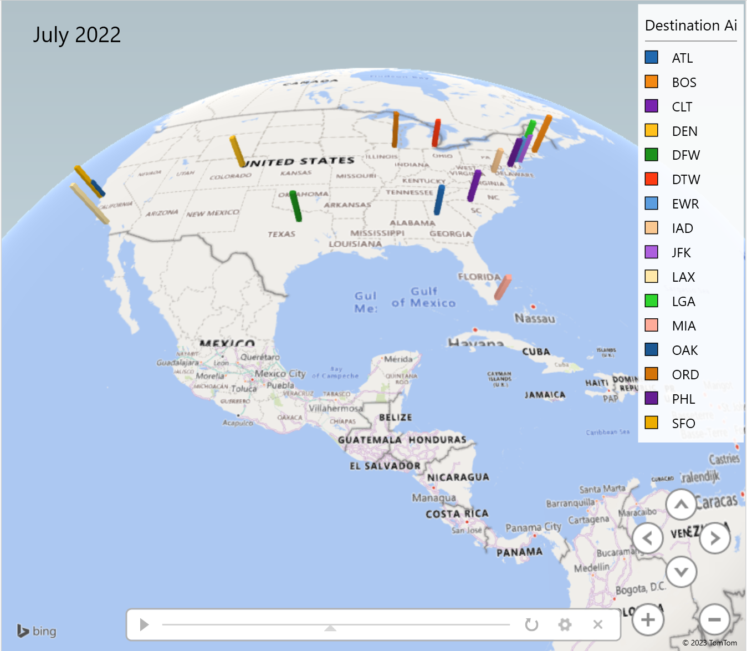

*Figure 6 – Popular Destination Airports Over Month*

Figure 6 is an animated 3D map in Excel that shows flight data from April to December 2022 utilizing a timeline across different months. To represent popular destinations, we used a bar chart that displays the total number of flights for each month. The time attribute is used to visualize which destinations experienced more flights during specific months. In the time column, month-year format has been chosen. This visualization is available in video format clearly displaying the size of each bar increasing during August and September, then decreasing until November. This format effectively illustrates the changes in flight patterns over time.

6.5. Pie Chart in Tableau

*Figure 7 – Distribution of Basic Economy Tickets*

It can be interpreted from Figure 7 about the distribution of Basic Economy Tickets. The chart is divided into two slices: one labeled "True" and the other labeled "False". The "True" slice is represented in orange and indicates the proportion of Basic Economy Tickets, which accounts for only 15% of the total dataset. Meanwhile, the "False" slice represents the percentage of Non-Basic Economy Tickets, which comprises 85% of the dataset. The size of the "True" slice is much smaller than the "False" slice, highlighting that Basic Economy Tickets are a relatively small proportion of the overall Flight Prices dataset.

## Conclusion

## In summary, this report presents an analysis of flight prices from April to November 2022. The results of this analysis will assist travelers in finding the best flight deals, while also enabling the airline industry to meet consumer demand, increase revenue, and provide a positive customer experience.

## Based on the data analysis, the following points can be summarized:

1. The report highlights the top and least 10 flight routes based on the number of tickets sold.
2. The report also identifies the top 15 most expensive flight routes, based on the ticket price.
3. In June, airfare was found to be higher in comparison to the traveled distance.
4. In August and September, the majority of destination airports experienced higher traffic.
5. It was observed that airlines offer only a small proportion of basic economy tickets.

However, it should be noted that this dataset only contains information on flights to and from 16 airports. Further research could be conducted by analyzing data from additional airports to gain a more comprehensive understanding of the trends in the airline industry.

For the complete project document repository (term-paper, PowerPoint slides, and code), visit the following GitHub link: <https://github.com/amach3/Flight-Price-Analysis>

# References

[1] Abdella, J.A., Zaki, N.M., Shuaib, K., & Khan, F. (2021). Airline ticket price and demand prediction: A survey. Journal of King Saud University - Computer and Information Sciences, 33(4), 375-391. <https://doi.org/10.1016/j.jksuci.2019.02.001>.

[2] Greenberg, P. (2022, November 6). Busiest airline routes in the U.S. <https://petergreenberg.com/2022/11/04/busiest-airline-routes-in-the-u-s/>

[3] Distance from Newark to New York (EWR – LGA). Air Miles Calculator. (n.d.). https://www.airmilescalculator.com/distance/ewr-to-lga/